1.

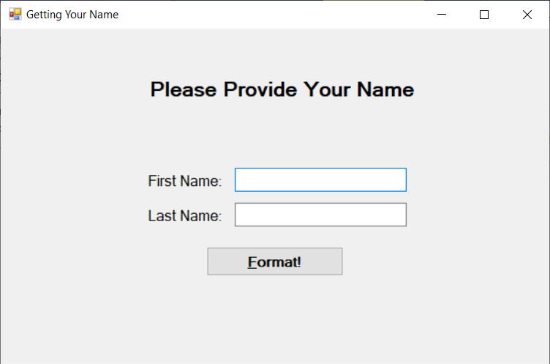

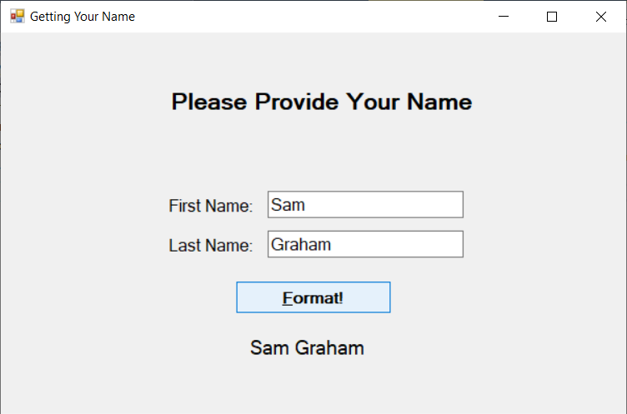

using System;

using System.Windows.Forms;

namespace COP_2360_A12

{

public partial class Form1 : Form

{

public Form1()

{

InitializeComponent();

}

private void button1_Click(object sender, EventArgs e)

{

LblDisplayName.Text = txtFirstName.Text.PadLeft(12) + " " + txtLastName.Text.PadRight(12);

LblDisplayName.Visible = true;

}

}

}

2.

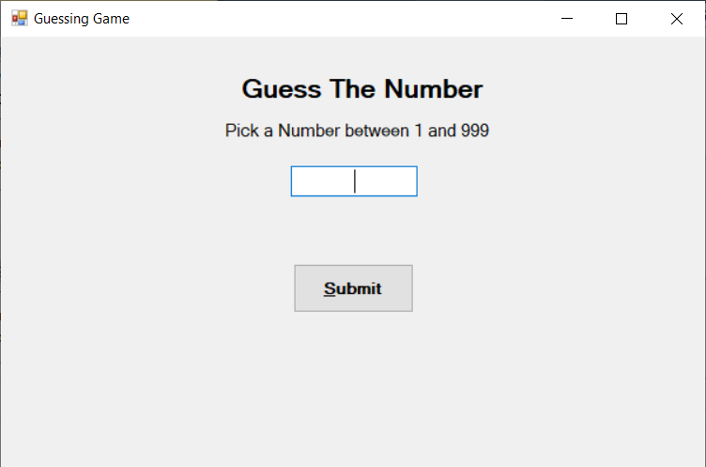

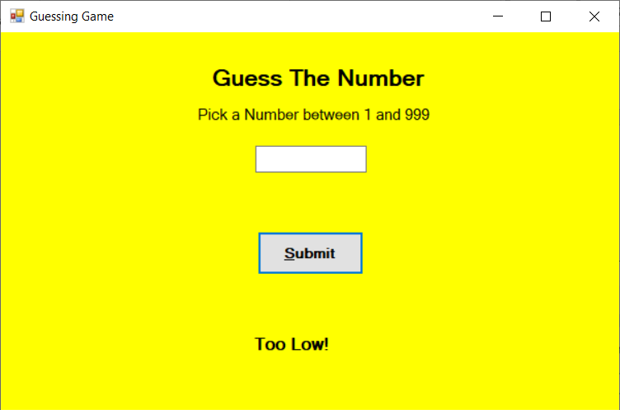

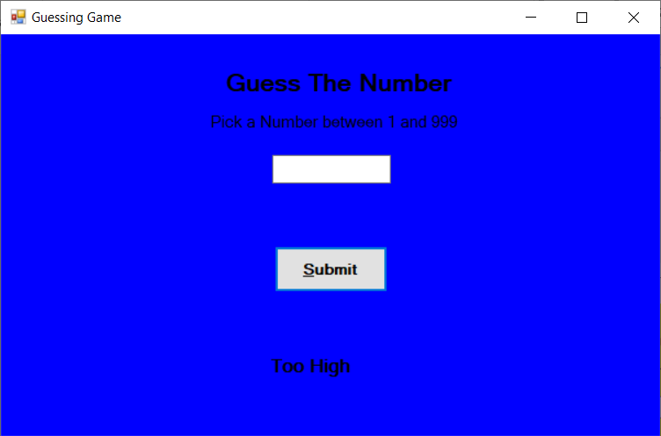

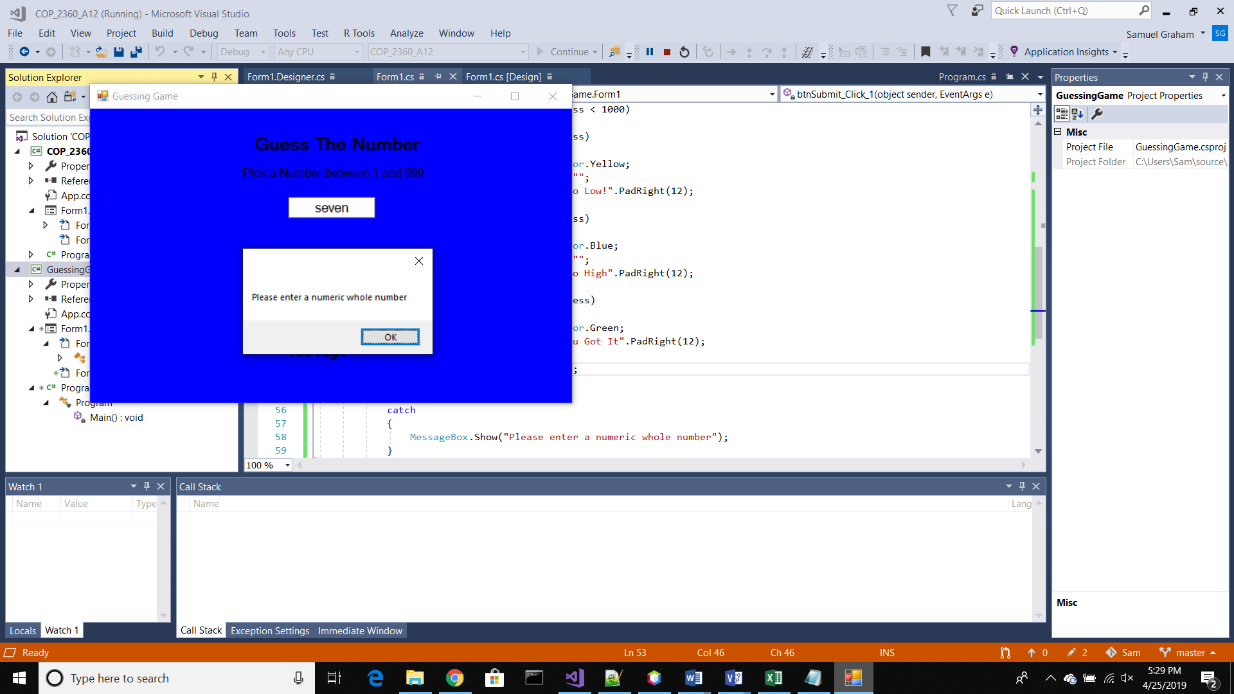

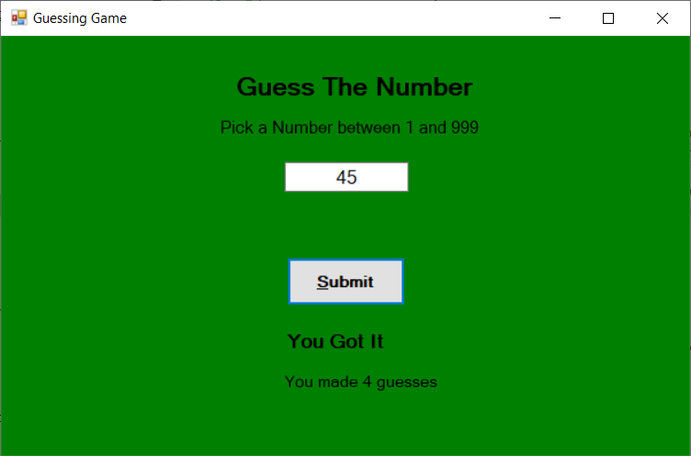

using System;

using System.Drawing;

using System.Windows.Forms;

namespace GuessingGame

{

public partial class Form1 : Form

{

int numToGuess;

int numofGuesses = 0;

public Form1()

{

InitializeComponent();

}

private void Form1_Load(object sender, EventArgs e)

{

Random random = new Random();

numToGuess = random.Next(1, 1000);

int numofGuesses = 0;

}

private void btnSubmit_Click_1(object sender, EventArgs e)

{

int userGuess;

++numofGuesses;

try

{

userGuess = Convert.ToInt32(txtUserGuess.Text);

if (userGuess > 0 && userGuess < 1000)

{

if (userGuess < numToGuess)

{

this.BackColor = Color.Yellow;

txtUserGuess.Text = "";

lblResult.Text = "Too Low!".PadRight(12);

}

if (userGuess > numToGuess)

{

this.BackColor = Color.Blue;

txtUserGuess.Text = "";

lblResult.Text = "Too High".PadRight(12);

}

if (userGuess == numToGuess)

{

this.BackColor = Color.Green;

lblResult.Text = "You Got It".PadRight(12);

lblNumOfGuesses.Text = "You made " +

Convert.ToString(numofGuesses) + " guesses";

lblNumOfGuesses.Visible = true;

}

lblResult.Visible = true;

}

}

catch

{

MessageBox.Show("Please enter a numeric whole number");

}

}

}

}